Guide Specification for Drinking Water Wells

Various Locations, Afghanistan

# general

This specification is to be used in the design and construction of the new water well at ?????????????. Additional guidance for information contained in this specification can be found in the document entitled AED Design Requirements – Well Pumps and Well Design – Sep 09. The publications listed below form a part of this specification to the extent referenced. The publications are referred to in the text by the basic designation only.

## LOCATION AND DEPTH OF WELL

The test well to be constructed shall be located as shown on the drawings, or where directed by the Contracting Officer (CO) or his representative (COR). The well shall be to such depth as may be necessary to penetrate a desirable water‑bearing stratum. The minimum well depth for each well shall be 20 meters below the static water table. Additional depth to be determined based on the experience of the driller and similar wells in the area may be required by estimating the additional depth that may be required to provide a minimum 10 meters of submergence over the well pump during the dynamic drawdown depth of water during pumping. It may be necessary for the well depth to penetrate the full thickness of the aquifer to bedrock to achieve sufficient depth.

## LOCAL CONDITIONS

Hydrogeological and water-well information for the immediate vicinity should be obtained locally from private and/or government organizations. The driller should drill test hole as hereinafter specified to assure the water availability of the aquifer. The method of drilling and the type of well construction may vary depending on the local geology. Wells completed into unconsolidated aquifers may need to be screened depending upon the type of aquifer material or if completed into consolidated (rock) aquifers, open-hole construction may be approved.

# PROTECTION OF EXISTING FACILITIES

The existing facilities such as building structures, utilities, walks, trees, etc., except as otherwise specified in these specifications, shall be protected from damage during con­struction of the wells, and if damaged, shall be repaired by the Contractor at his expense. Water pumped from the well shall be conducted to a place where it will be possible to dispose of the water without damage to property or the creation of a nuisance.

# PROTECTION OF QUALITY OF WATER

The Driller shall take all necessary precautions during construction to prevent contaminated water, gasoline or other contaminated materials from entering the well either through the opening or by seepage through the ground sur­face. The Driller shall exercise extreme care in perfor­mance of his work in order to prevent the breakdown or caving of the strata overlying that from which the water is to be drawn.

# TEST WELL DEVELOPMENT

## General

Before perma­nent well construction, at least one test well of at least 150mm in diameter and minimum 20 meters below the static water table shall be drilled into the water bearing stratum or the top of bedrock. A GPS instrument will be used to determine the geographic coordinates of the well. This information shall meet requirements of the World Geodetic System 1984 (WGS 84 UTM Zone 42) in decimal degrees. The test hole shall be used to determine the location and character of the water bearing strata and to obtain samples of the various formations. Samples of drilling cuttings shall be taken at every change of strata and at depth intervals not to exceed 1.5 meters. A split spoon sample shall be taken at each major change in strata as indicated by the nature of the cutting samples. A driller's log shall be made based on the cuttings obtained. The final selection of the screen settings, the proper gravel filter pack material, and the depth of grouting will submitted to the COR for approval prior to any additional work. The drill cuttings shall be divid­ed, put into suitable containers and labeled. These samples shall be approximately half a liter each. If the test hole fails to indicate the presence of water bearing strata or is abandoned for any other reason, the test hole shall be grouted from the bottom to the top with cement grout as hereinafter specified and in a manner approved by the COR. At the completion of the test hole, a drillers log shall be prepared containing the following information that shall be included in the submittals:

## driller’s log contents

1. Depth of water strata
2. Depth of different material strata contacts
3. Color, size, and soil description of cuttings
4. Penetration rate (meters per day)
5. Types and amount of drilling fluid gain or loss
6. Type schedule and length of well casing

## TEST WELL PUMPING

To determine the expected yield from the well and to assure acceptable water quality, a pump test shall be performed in the candidate test well. A temporary casing and screen, if required, shall be used to construct the test well for completion of a 4-hour capacity test using a temporary pump with the capacity to pump the required average daily demand supplied by the pump. The static water level in the well should be measured prior to installing the pump and the water level at the end of the pumping period should be measured. The temporary casing shall be a minimum diameter of 150mm and extend to the top of the water‑bearing strata being tested in unconsolidated formations. The Contractor shall isolate other water bearing strata present from discharging into the test well. After completion of the test well, all data pertaining to the construction of the well shall be shown on a sketch of the test well with all pertinent depths of construction.

## submittal for Approval of TEST WELL

Before any further construction in the test well, a copy of the results of the test hole drilling log and test well capacity test results shall be submitted to the COR for approval. Upon approval the permanent well construction may begin. Contents of the test well approval submittal shall include:

(a) Location of well on site plan.

(b) Size of well diameter and depth.

(c) Drilling log showing depths of aquifer strata.

(d) Depth below top of well of static water table.

(e) Casing and screen diameters and lengths installed in the well.

(f) Setting of casings, screens, and grouting of casings.

(g) Placement depths of gravel pack material, if used.

(h) Test well pumping rate, liters per second

(i) Test well drawdown record (see Table 5)

(j) Water quality result (see Table 4)

## Abandonment of unapproved wells

Test wells not approved will be abandoned in accordance with specifications in Reference 1.4, AWWA A 100.

# WELL CONSTRUCTION

## GENERAL

Well construction shall be based on well design guidelines set by the US Army Corps of Engineers Afghanistan Engineer District Well Pumps and Well Design Guide, September 2009. The execution of the work shall be by a competent crew performed under the direct supervision of an experienced well driller acceptable to the COR. The well shall be drilled essentially straight, plumb and circular from top to bottom. The type of well construction, as determined by the test hole, shall be either an artificially gravel‑packed well, a naturally developed well or a rock wall well. The presence of cavities and voids in the formations being penetrated will make the construction of a screened well difficult due to loss of the filter material into the cavity. Grouting may also be affected by these voids. If cavities and voids are encountered in the test hole, the Contractor shall consider this in the design of the completed well and submit this information with the results of the test hole and test well. The well shall be constructed and developed to produce clear water with a minimum of drawdown. Wells not meeting the criteria for water quality, Section 10 WELL DEVELOPMENT, will not be acceptable. Well and casing dimensions shall generally be within the following ranges shown in Table 1.

TABLE 1 Minimum Required Well and Casing Diameters



## SURFACE CASING

Surface casing shall be used on all wells. This casing may be left in place or removed at the option of the driller. If the surface casing is to be left in place, the surface casing shall be grouted into place for the full length of the casing. In unconsolidated aquifer material, casing shall be extended to the top of the well screen. In wells developed in rock formations, the hole may be left open with the casing extended three meters into the formation. All well surface casing shall be extended 0.5 meters above grade.

## WELL CASING

The well casing shall be of the size hereinafter specified and be constructed either of black steel meeting the AWWA C200 or PVC plastic Schedule 80 meeting ASTM 1785 and ASTM F480 specifications. Only standard weight black steel pipe shall be used as casing for wells over 80 meters deep and it shall conform to ASTM A-53 steel pipe conforming to AWWA Specification C‑200, as applicable. The minimum steel casing thickness shall be 8 mm. Steel casing may be provided with drive shoes at the option of the driller. Steel pipe couplings shall be per ASTM F480. PVC casing may be used if well depths are less than 80 meters. The PVC pipe must be at least Schedule 80 or SDR 17. Driving of PVC casing will not be allowed. PVC pipe couplings shall be per ASTM F480. All casing used in the perma­nent well shall be new and unused. Cast iron pipe shall not be used for well casing or screens. Sufficient casing cen­tralizers shall be used to keep casings centered in the hole. Each section of casing will be joined with standard couplings; full-threaded joints, proper welding or solvent cement PVC welds so the joints are sound and watertight. Well casing alignment shall not interfere with the proper installation and operation of the pump.

## CEMENTING WELL CASING

The annular space between the well casing and the walls of the hole shall be filled with cement grout or crushed angular gravel as hereinafter specified. The grout shall be proportioned of Portland cement conforming to ASTM Specifi­cation C‑150, Type I or II and the minimum quantity of water (not over 23 liters per 42.3 kg of cement) required to give a mixture of such consistency that it can be forced through the grout pipes. The method for placing the grout will be by the forcing of the grout from the bottom of the space to be grouted towards the surface. The minimum depth of grouting shall be three meters unless approved in writing by the COR. The grout shall also seal off any other water bearing strata above the zone that is producing the water to the well. The grouting shall be done continuously and in a manner that will insure the entire filling of the annular space in one operation without damaging the well casing. No drilling operations or other work in the wells will be permitted within 24 hours after the grouting operation to allow the grout to properly set. Up to 5% bentonite may be added to the mixture to reduce shrinkage of the grout. The addition of bentonite will require additional water at the ratio of 2.5 liters of water for each percent of bentonite added. The bentonite slurry shall contain at least 20 percent solids by weight by having a density of 4.3 kg/L. Aggregate requirements for sealing the solid wall casing and edge of the borehole area shown below:

|  |  |
| --- | --- |
| **Sieve size, mm** | **Percent total weight passing** |
| 12.5 | 100 |
| 4.75 | 75 +/- 13 |

## WELL SCREEN

The well screen and attached fittings shall be constructed entirely of corrosion resistant stainless steel, unless otherwise specified. Steel screens shall be made from Type 304 stainless steel meeting the requirements of AWWA A100 because of high chloride concentrations that corrode metals. Screens made of UPVC pipe material shall not be permitted. The screen slot pattern shall be continuous slot, wire wound or slotted PVC pipe design. Slot openings shall be continuous around the screen, spaced to provide open area required for maximum entrance velocity criteria, but be consistent with the strength requirements, and should be V-shaped toward the inside of the screen to reduce clogging. Slot sizes shall be typical sizes per manufacturer specifications (see Table 2). Vertically slotted metal casing may be used in only in lower yielding deep (greater than 300 m) wells where extra pipe strength is required and shall require COR approval. PVC pipe screens shall be manufactured from Schedule 80 PVC pipe. Metal screens shall be used for wells greater than 80 meters in depth. The minimum inside diameter of the well screen shall be 150mm. Minimum total length of PVC screens installed in the permanent well shall be four (4) meters. Minimum total length of steel screens shall be two (2) meters. Well screens shall provide adequate transmitting capacity to limit the entrance velocity to less than 0.03 m/sec (0.1 ft/s). The selected screen slot design shall be based on standard manufacturer specifications and meet the minimum effective open area required for entrance velocity criteria. Well screen design information shall be submit­ted to the project COR for approval prior to installation. In a gravel pack well, the screen shall have a slot size based on the gradation of the filter material which is indicated in 9.7 GRAVEL‑PACKED WELL. PVC slotted screens shall be machine milled by a recognized screen manufacturer and not hand cut in the field. Field fabricated screens are not permitted. Appendix B shows examples of unacceptable and acceptable well screens. The well screen shall be directly connected to the top of the inner casing. The bottom of the screen shall be sealed with a positive closure. A wash‑down shoe may be used if desired. The screen used in a gravel‑packed well shall be carefully lowered into the water‑bearing strata and be centered in the hole. In a naturally developed well (see 9.6 NATURALLY DEVELOPED WELL), the slot size of the screen will be based on a mechanical sieve size analysis of the natural water bearing sediments. The well screen and all acces­sories required for satisfactory installation shall be essentially standard products of reliable manufacturers regularly engaged in the production of such equipment. Field welding of screen components shall be accomplished using products made to weld such products together in a reliable manner.

### Well screen submittal

Well screen submittal information shall include:

(a) Number of screens and depth of setting in the well.

(b) Size of well screen inside and outside diameters and length.

(c) Pipe material (material schedule and specification).

(d) Standard slot opening, mm

(e) Effective open area of screen (sq cm per meter)

(f) Transmitting capacity (liters/meter)

(g) Sieve analysis of the material to be screened

(h) Calculations supporting screen slot size

(i) Photo of screen slot pattern

TABLE 2 Typical Effective Open Area for Slotted Well Screens



Figure 1 Minimum Effective Open Area versus Well Yield



# well types

## NATURALLY DEVELOPED WELL

In water bearing coarse grained material defined as gravel, cobbles, and conglomerate more water can be obtained by natural development of the permeable zone around the well screen than using a gravel pack. After setting the surface casing, a natural­ly developed well shall be initially drilled by reaming the test hole from the ground surface to the lower level of the water‑bearing strata. The well casing and screen shall not be less than 150mm in diameter. The hole shall be of sufficient size to leave a concentric annular space of not less than 50mm between the outside of the casing and the walls of the hole. A grouting basket shall be used to keep the grout from invading the zone around the well screen. The space around the casing shall be filled with cement grout as herein­before specified. After grouting is completed, drilling operations shall not be resumed for at least 24 hours to allow proper setting of the grout. After the grout has set, the well shall be developed by pumping or bailing until the fine grained material is removed.

## GRAVEL‑PACKED WELL

### GENERAl

Gravel-packed wells shall be constructed in fine grained aquifer materials consisting of silty sand, sand and fine gravel (less than material 3 mm in size). The space around the well screen shall be filled with gravel pack material as described hereafter; either gradation A or gradation B shall be used based on a mechanical sieve size analysis of the natural water bearing sediments. The term “gravel-packed well” does not actually mean that the filter material is always gravel sized material. The filter material may be sand sized. The gradation depends upon the size of the aquifer material that yields the water. Coarse grain aquifers shall be considered to be any water bearing stratum that has more than 50 percent of the individual particle sizes greater than 6 mm in diameter. Aquifers with greater proportion of fine sand and silt (less than 6 mm size) shall be considered fine grained aquifers. After setting the surface casing, a gravel-packed well shall be initially drilled by reaming the test hole from the ground surface to the lower‑most level of the water bearing strata. The casing and screen shall be as herein specified and shall be not less than 150mm in diameter. The hole shall be of sufficient size to leave a concentric annular space of not less than 50mm between the outside of the screen and casing and the walls of the hole. The gravel pack shall be 1.5 times the length of the screen section it surrounds. For example if the screen is 3 meters in length the gravel pack shall be 4.5 meters in length straddling the screen on the top and bottom. The space around the screen shall be filled with filter material as hereinafter specified. The well casing shall be grouted in with cement grout as herein­after specified. After grouting is completed, drilling operations shall not be resumed for at least 24 hours to allow proper setting of the grout. The hole below the outer casing shall penetrate the water bearing strata a sufficient depth to install the well screen and produce the required yield without causing excessive velocities through the well screen. The casing shall be connected directly to the top of the well screen and extend up to one foot above the ground surface.

### GRAVEL‑PACK

After the screen and casing have been installed, filter material shall be installed around the screen by filling the entire space between the screen and the walls of the hole with filter material. The filter shall have a wall thickness of 50mm, measured from the outer edge of the screen to the wall of the hole. Filter material shall be of properly sized, graded, well-rounded natural sand and gravel suitable for the strata encoun­tered. Angular aggregate shall not be used. The filter material shall be of such size as will allow the maximum flow of water into the well and prevent the infil­tration of sand. It shall be washed siliceous material, reasonably smooth and round and free of flat or elongated pieces as well as dirt, vegetable matter or other foreign matter. The Driller shall demonstrate to the COR that the filter material is suitable for the conditions prior to placement and submit a gradation of the material for approval. In no case will improp­erly sized filter material be added around the screen.

Gravel pack gradations shall be based on the aquifer particle size. Silty sand particle size aquifers shall use Gradation A (Table 3), and gravel and larger particle size material shall use Gradation B (Table 4).

TABLE 3 Gradation A Gravel Pack Materials

Material for gravel pack in silty sand aquifers - Shall consist of stone containing rounded shapes and surfaces with no flat surfaces having the following gradation:

Sieve Size % Total Wt. Passing

12.5 mm 100

4.75 mm 75 +/- 13

1.18 mm 25 +/- 15

0.425mm 8 +/- 4

TABLE 4 Gradation B Gravel Pack Materials

Material for gravel pack in sandy gravel including cobbles - Shall consist of stone containing rounded shapes and surfaces with no flat surfaces have the following gradation:

Sieve Size % Total Wt. Passing

40 mm 100

32 mm 75 +/- 13

16 mm 25 +/- 15

9 mm 8 +/- 4

All aggregate shall contain less than 5% by weight rock powder, silt, clay, shale, clay lumps, coal, lignite, soft stone, or other deleterious materials.

### PIPE OR CONDUCTOR FOR FILTER PLACEMENT

If possible, a pipe or conductor having an inside nominal diameter of not less than 25mm shall be lowered to the bottom of the well between the drilled hole and the screen. It shall be so arranged and connected at the surface of the ground to water pumping and filter placement equipment so that water and filter material, fed at uniform rates, are discharged through it as the filter fills the hole from the bottom up. The filter sand and water conductor shall be raised at the rate that will keep the bottom of the pipe approximately at the filter material level in the hole.

## ROCK WELL

A rock well shall be initially drilled from the ground surface to a point at least 3 meters below the top of consolidated material (bedrock), but not less than 10 meters below the top of the rock and the bottom of the casing shall be set at this bottom eleva­tion. The finished internal diameter of the casing shall be not less than 150mm, and the hole shall be drilled to a sufficient diameter so as to leave a concentric annular space not less than 37mm (1 1/2‑inches) between the casing and the walls of the hole. A temporary casing may be used to pre­vent caving of the hole walls, but the temporary casing must be removed when the grouting of the permanent casing is performed. This space shall be filled with cement grout in a manner as previously specified. After the grouting is completed, drilling operations shall not be resumed for at least 24 hours to allow proper setting of the grout. Drill­ing into the water‑bearing rock strata shall be resumed after the grout has set. A hole at least 150mm in diameter, concentric with the casing above, shall be drilled into the water‑bearing rock a sufficient depth to produce the required amount of water without causing excessive velocities of the water through the rock.

# WELL DEVELOPMENT

After completion, the well shall be thoroughly developed. The developing equipment shall be of sufficient capacity to remove all drilling fluids, sand, rock cuttings or any other foreign matter. The wells shall be thoroughly cleaned from top to bottom before beginning the well tests. The recommended type of development for stainless steel screened wells is hydro‑jetting; however surge blocks, air‑development or other development techniques are permissible at the option of the Contractor. The well shall be disinfected before removing the test pump and collecting samples for determining the water quality (see

# WELL PUMPS

## PERMANENT WELL PUMP

The pump and motor diameter shall be at least 25 mm smaller than the inside diameter of the well screen or casing, whichever is smaller, in order to allow it to be removed for servicing after the buildup of scale on the outside of the pump and inside of the screen and casing. Before any installation of the permanent pump in the well, a pump design approval shall be submitted to the COR for approval.

## submittal

Pump design approval submittals shall include the following information:

(a) Capacity of well from test well submittal.

(b) Size of permanent well diameter and depth.

(c) Depth of static water level below top of well.

(d) Power source and pump motor electrical power requirements.

(e) Expected well draw down.

(f) Pump discharge piping diameter, length, fittings and appurtenances (valves, meters, etc.)

(g) System total dynamic head required by well pump.

(h) Pump design discharge rate.

(i) Selected pump curve and duty point from manufacturer.

(j) Pump/motor product material specifications from manufacturer.

## HAND PUMP

A standard hand pump with seal and air gap shall be installed on the permanent well discharge piping to discharge at concrete pad around well if required by the contract technical requirements. The hand pump shall be capable of pumping at a minimum pressure head of 138 Kpa (20 psi) in the event there is either a loss of power supply or a pump failure in the water well system.

# WELL HEAD COMPLETION

A stainless steel check valve (if not on the pump discharge piping), isolation valve, sampling port, and well discharge tantalizer shall be installed on the pump discharge pipe line, as minimum appurtenances, between the well head and the water storage treatment tanks. A water level measurement port shall be provided at the well head. Additional appurtenances such as flow meter, air release valve, and chlorination treatment piping may be required depending upon the contract technical requirements. Any structure built over the well must have a large door in the roof that allows for easy removal of the pump piping and pump using an overhead crane. Examples of well head construction are shown in Append B.

# TESTS

## TEST FOR QUALITY OF WATER

During the testing of the test well and again during the yield and drawdown test in the permanent well, the Contractor shall schedule to obtain a preliminary sample of the water in suitable contain­ers and of sufficient quantity to have bacterial, physical and chemical analyses made in accordance with the following Table 5 to determine if the water is potable. The word "potable" for purpose of this contract is further defined as water that is suitable for drinking by the public, i.e., good, clear water free from objection­able amounts of harmful bacteria and chemical and physical properties, as defined by References 1.1 or 1.2. Sampling shall be performed by qualified personnel who must obtain sampling kits and schedule their site visit to obtain the samples as directed. The coordination with the COR for the sampling and analysis should begin at the beginning of the contractual period.

TABLE 5

WATER QUALITY ANALYSIS TABLE

Physical Characteristics

Color Temperature

Threshold odor number pH value

Turbidity

Chemical Characteristics (Expressed as mg/L)

Arsenic Total Hardness as Ca(CO)3

Barium Cadmium

Chromium Copper

Lead Mercury

Selenium Silver

Zinc Sulphates as SO4

Fluoride as F Chlorides as Cl

Manganese as Mn (dissolved Conductivity

and total)

Iron as Fe (dissolved and Nitrites as NO2

total)

Total Dissolved Solids Nitrates as NO3

total coliform/fecal coliform (bacteria)

## TEST FOR SAND

After the final well is fully developed and while the development pump is still installed, a test for sand shall be conducted. The well shall be allowed to rest for at least one hour, then pumping shall begin at the full design well yield. Driller shall pump or bail the well until the water pumped from the well shall be substantially free from clay, silt, and sand (< 8.0 mg/l) as measured by an Imhoff cone container or until the water is clear (which shall be determined by the COR. The Imhoff cone container results shall be based on the average results of five samples taken from a large barrel or other tank during the pump test. The samples shall be taken 15 minutes after the start of the pump test, after 25%, 50% and 75% of the pump test duration, and near the end of the pump test. After completion of the well, unless the permanent pump is immediately installed, the Contractor shall cap the well to prevent contamination of the well.

## TEST FOR YIELD AND DRAWDOWN

Upon completion of the permanent production well, the Driller shall install the pump with discharge piping of sufficient size and length to conduct the water being pumped to a point of safe discharge and all equipment necessary for measuring the rate of flow and the water level in the well. A continuous 6-hour pumping test shall be conducted with the pumping rate and drawdown recorded approximately at the intervals indicated in Table 6.

TABLE 6 Time Intervals for Drawdown and Recovery Readings

½ minute

1 minute

2 minutes

3 minutes

4 minutes

5 minutes

7 minutes

10 minutes

15 minutes

20 minutes

30 minutes

60 minutes

120 minutes

240 minutes

360 minutes

Repeat the reading schedule above for duration of recovery portion of the test after the pump is shut off. Monitor the recovery of the well 24-hours after the pump is shut down.

# DISINFECTION

Immediately after the well is completed, unless the permanent pump is ready for installation, the well shall be sterilized by adding chlorine or hypochlorite in such volume and strength and shall be so applied that a concentration of at least 50 ppm shall be obtained in all parts of the well. The chlorine or hypochlorite shall be prepared and introduced into the well in a manner approved by the COR and shall remain in the well for a period of at least twelve hours. Section A1‑10 of AWWA Speci­fication A100 describes acceptable methods of sterilization of a well. After the contact period, the well shall be pumped until the residual chlorine content of the well water removed is 1 ppm or less.

# ABANDONMENT OF WELLS

In the event that the Contractor fails to construct a well of the required capacity, or should he abandon the well because of loss of tools or for any other cause, the Contractor shall fill the entire hole with grout and remove the casing to the satisfaction of the site COR.

# CLEAN‑UP

Upon completion of the well and other incidentals, all debris and surplus materials resulting from the work shall be removed from the job site. The drilling fluid shall be pumped out and properly disposed of and the excavation for the sump backfilled suitable to the site COR.

# QUALITY CONTROL

The Driller shall establish and maintain quality control for operations under this section to assure compliance with specification requirements and maintain records of his quality control for all materials, equipment, and construction operations, including but not limited to the following:

(a) Protection of existing facilities.

(b) Protection of quality of water.

(c) Drilling, logging, and testing of test holes.

(d) Drilling operations for well.

(e) Setting of casings, screens, and grouting of casings.

(f) Placement of filter material, if used.

(g) Well development.

(h) All testing of finished well.

(i) Well disinfection.

(j) Filling abandoned test hole or well if required.

A copy of these records and tests, as well as records of corrective action taken, shall be maintained by the Driller for review if requested by the COR.

# SUBMITTALS

Attachment A contains a flow chart of the drilling process and identifies the points where submittals are expected. The following summarizes the submittals previously listed in greater detail in this specification.

(a) Test well approval.

(b) Well screen approval and gravel pack gradation.

(c) Pump design approval.

(d) Drilling operations for well.

# PAYMENT

Payment for the production water well, except test hole (and test well), will be included in the contract lump sum price for "Water Well" which payment shall constitute full compensation for all costs in connection therewith. Payment for test hole and test well, if permanent well cannot be developed, as determined by the Contracting Officer, will be made at the contract unit price per linear foot for "Test Hole (and Test Well)", which payment shall include all labor, mobilization and demobilization of equipment, drilling, testing, materials, and other incidentals necessary for the test hole and (test well). Payment for test hole and (test well) used in the permanent well will be included in the contract lump sum price for "Water Well." Payment for linear footage of hole drilled not resulting in a permanent well will be paid for as linear footage of "Test Hole (and Test Well)."

**Attachment A - Water Well Construction Process**



**Attachment B**

**Examples of Unacceptable and Acceptable Well Construction**

**(Source: Statement of work Military Water Well Construction, Testing and Completion, United States Forces, Afghanistan, 2009)**

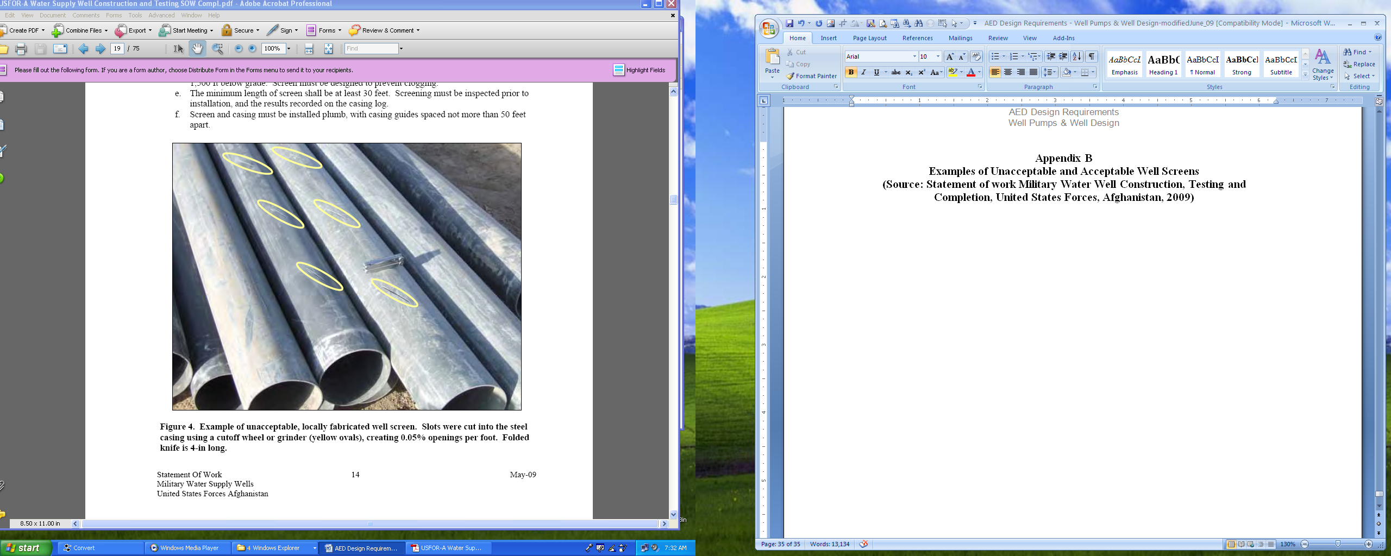

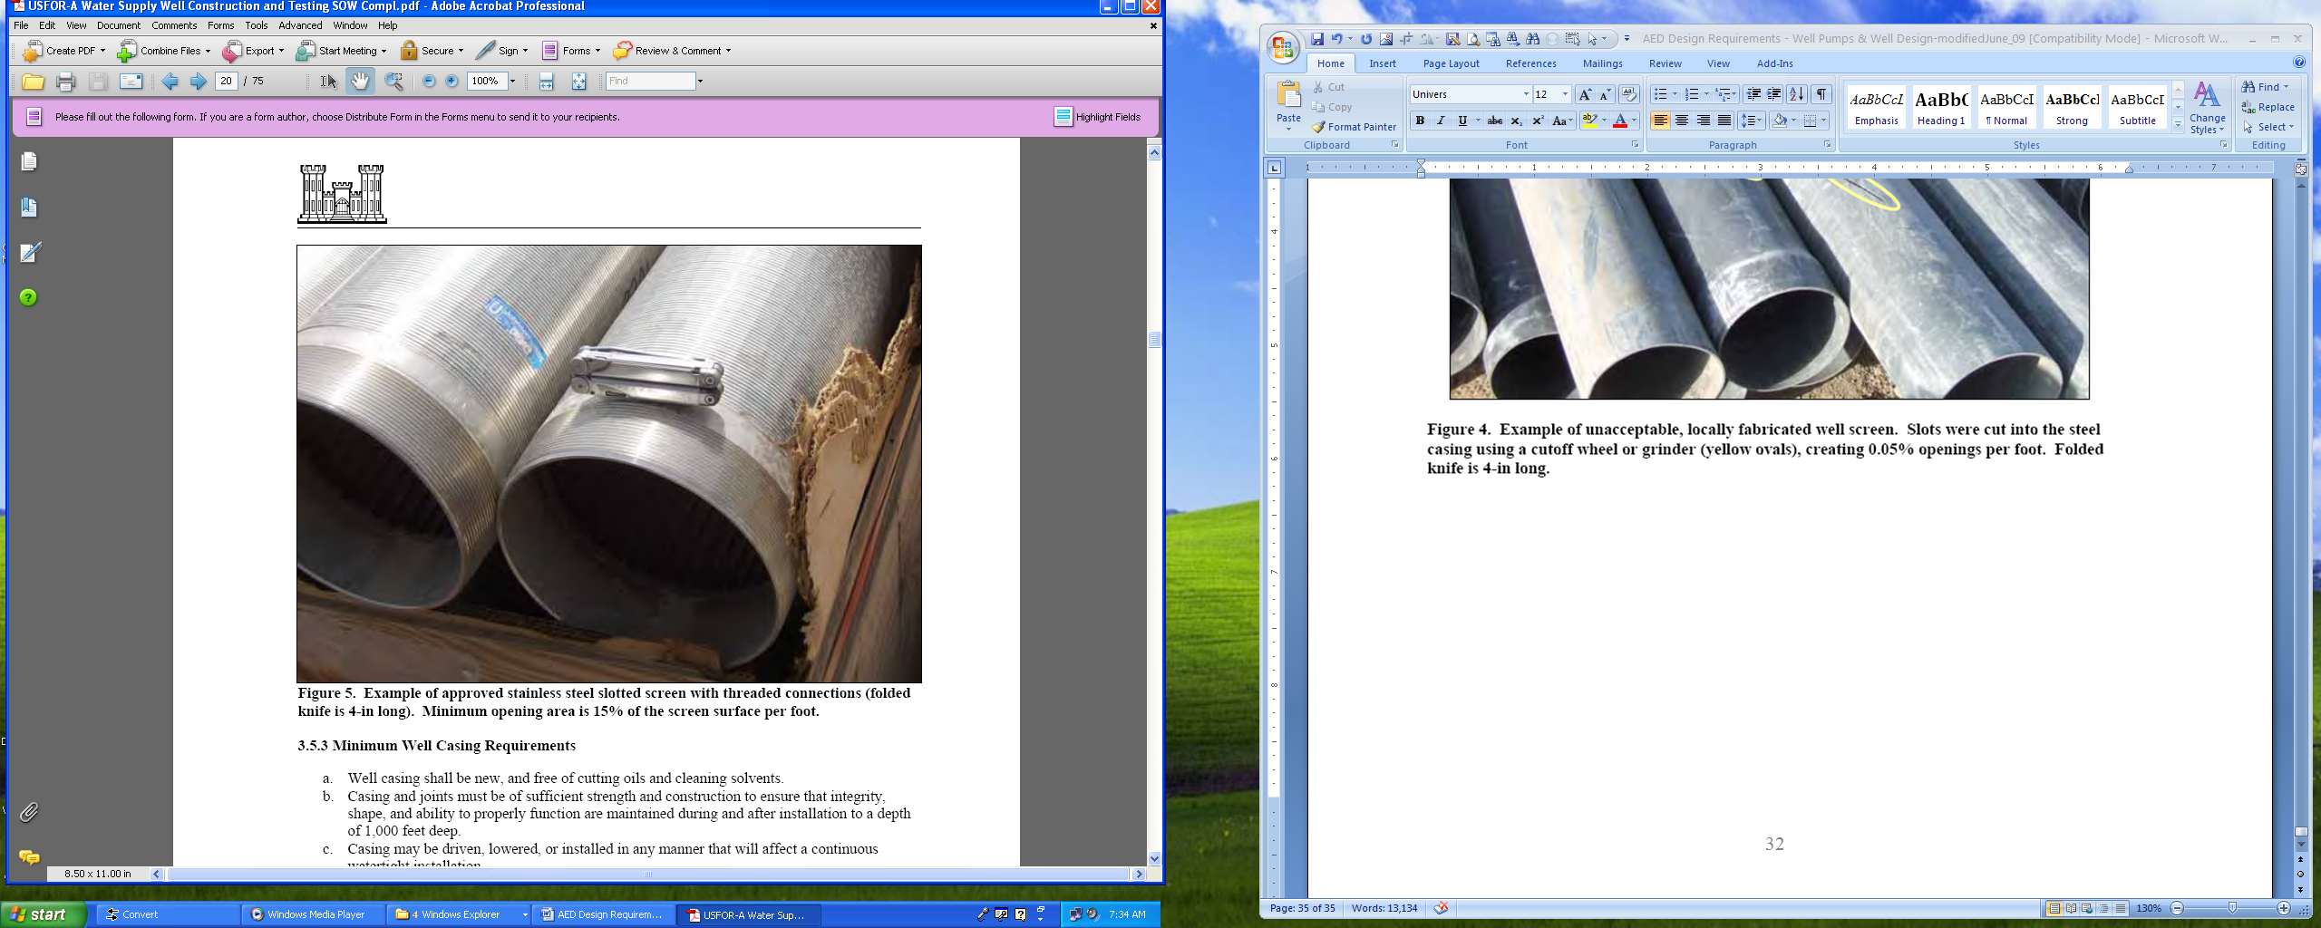

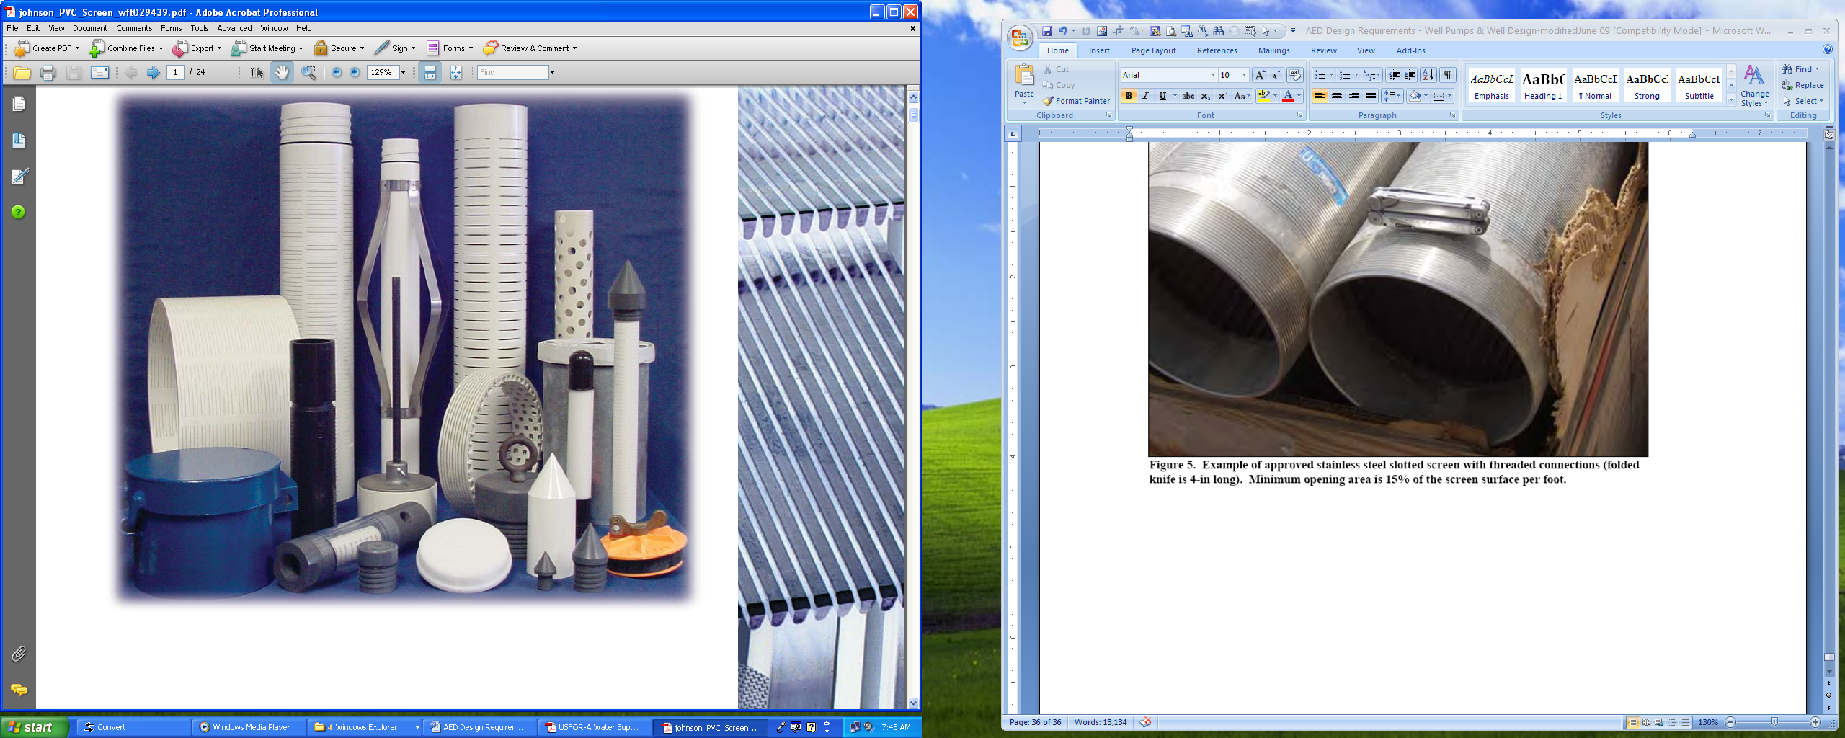

**Figure 6. PVC Schedule 40 slotted well screens**

